Supplementary material

**Sexually dimorphic blue bands are intra-sexual aposematic signals in non-territorial damselflies**

Md Kawsar Khan1*, Marie E. Herberstein1

1. Department of Biological Science, Macquarie University, NSW-2109, Australia

Author for correspondence: ([kawsar.khan@mq.edu.au](mailto:kawsar.khan@mq.edu.au))

Methods and materials

We applied the receptor noise model (Vorobyev, Osorio, Bennett, Marshall, & Cuthill 1998; Misha Vorobyev & Osorio 1998) to analyse how the male blue bands and female abdominal black coloration will appear to conspecifics. Damselflies can have trichromatic (Huang, Chiou, Marshall, & Reinhard 2014) or tetrachromatic (Outomuro, Söderquist, Johansson, Ödeen, & Nordström 2017) visual systems. As we do not know the visual system of *X. erythroneurum* damselfly, we used both trichromatic and tetrachromatic system. We ran the visual modeling in pavo v. 1.0.0 (Maia, Eliason, Bitton, Doucet, & Shawkey 2013) implemented in R v. 3.4.1 (2017).

First, we calculated the quantum catch (Qi) for each photoreceptor i as follows-

Qi = $\int_{300}^{700}{S\left(λ\right)I\left(λ\right)Ri}\left(λ\right)dλ,$

Where $λ$ is the wavelength, $S(λ$) is the reflectance spectra of damselfly integument or each background leaf, $I\left(λ\right)$ is the light spectrum entering the eye, and Ri $\left(λ\right)$ is the spectrum sensitivity of the photoreceptor i. We used a standard daylight spectrum (D65) as $I\left(λ\right)$ (Wyszecki & Stiles 1982)

Then, we calculated the noise of each class photoreceptor (*e*i) as,

$e_{i}$ = $\frac{\overline{ω}}{\sqrt{n_{i}}}$.

Where *ω* is the Weber fraction assigned to each receptor and *n*i is the relative density of the receptor class *i*. We applied a Weber fraction of 0.12, which was successfully used in damselfly visual modeling (Schultz & Fincke 2013).The proportion of the photoreceptor of damselflies are not known. So we applied receptor density of another trichromat, the honey bee (1:0.471:4.412) (Defrize, Théry, & Casas 2010).

Finally, we calculated the chromatic contrast (ΔS) between the damselfly spectra and the background using the equation:

$$ΔS= \sqrt{\frac{{e_{1}}^{2}{(Δf_{3}- Δf_{2})}^{2}+{e_{2}}^{2}{(Δf_{3}- Δf_{1})}^{2}+{e_{2}}^{2} {(Δf_{1}- Δf_{2})}^{2}}{{(e_{1}e_{2})}^{2}+ {(e_{1}e_{3})}^{2}+ {(e_{2}e_{3})}^{2}}}$$

Where Δ*f*i is the log of quantum catches for receptor *i* between damselfly and the background.

Also, to calculate the achromatic contrast we used green photoreceptor like honeybee visual system and the achromatic contrast (ΔL) was calculated as:

ΔL = $\frac{Δfi}{e_{i}}$

For the tetrachromatic damselfly visual system we used photoreceptor sensitivities 366 nm, 480 nm, 552 nm, 640 nm ((Outomuro, Söderquist, Johansson, Ödeen, & Nordström 2017) photoreceptor density 2:2.5:2.5:1 (Armett-Kibel & Meinertzhagen 1983) and a Weber fraction 0.12 (Schultz & Fincke, 2013). We calculated the chromatic contrast $(ΔS)$ using the equation:

$$ΔS= \sqrt{\frac{\begin{aligned}{e_{1}e_{2}}^{2}{\left(Δf_{4}- Δf_{3}\right)}^{2}+{e_{1}e_{3}}^{2}{\left(Δf_{4}- Δf_{2}\right)}^{2}+{e_{1}e_{4}}^{2}{\left(Δf_{3}- Δf_{2}\right)}^{2}+ \\ {{+ {e_{2}e_{3}}^{2}{\left(Δf_{4}- Δf_{1}\right)}^{2}+{e_{2}e_{4}}^{2}{\left(Δf_{3}- Δf_{1}\right)}^{2}+e}_{3}e_{4}}^{2}{(Δf_{2}- Δf_{1})}^{2 }\end{aligned}}{{(e_{1}e_{2}e_{3})}^{2}+ {(e_{1}e_{2}e_{4})}^{2}+ {(e_{1}e_{3}e_{4})}^{2}+ {(e_{2}e_{3}e_{4})}^{2}}}$$

The achromatic contrast for the tetrachromatic visual system was calculated using the same equation for trichromatic visual system.

References:

Armett-Kibel, C., & Meinertzhagen, I. A. (1983). Structural organization of the ommatidium in the ventral compound eye of the dragonflySympetrum. *Journal of Comparative Physiology*, *151*(3), 285–294.

Defrize, J., Théry, M., & Casas, J. (2010). Background colour matching by a crab spider in the field: a community sensory ecology perspective. *Journal of Experimental Biology*, *213*(9), 1425–1435.

Huang, S., Chiou, T., Marshall, J., & Reinhard, J. (2014). Spectral sensitivities and color signals in a polymorphic damselfly. *PLoS One*, *9*(1), e87972.

Maia, R., Eliason, C. M., Bitton, P.-P., Doucet, S. M., & Shawkey, M. D. (2013). pavo: an R package for the analysis, visualization and organization of spectral data. *Methods in Ecology and Evolution*, *4*(10), 906–913.

Outomuro, D., Söderquist, L., Johansson, F., Ödeen, A., & Nordström, K. (2017). The price of looking sexy: visual ecology of a three-level predator–prey system. *Functional Ecology*, *31*(3), 707–718.

Schultz, T. D., & Fincke, O. M. (2013). Lost in the crowd or hidden in the grass: signal apparency of female polymorphic damselflies in alternative habitats. *Animal Behaviour*, *86*(5), 923–931.

Vorobyev, M., Osorio, D., Bennett, A. T., Marshall, N. J., & Cuthill, I. C. (1998). Tetrachromacy, oil droplets and bird plumage colours. *Journal of Comparative Physiology A*, *183*(5), 621–633.

Vorobyev, Misha, & Osorio, D. (1998). Receptor noise as a determinant of colour thresholds. *Proceedings of the Royal Society of London B: Biological Sciences*, *265*(1394), 351–358.

Wyszecki, G., & Stiles, W. S. (1982). Color Science Wiley. *New York*, *19672*, 344.

Supplementary figure S1

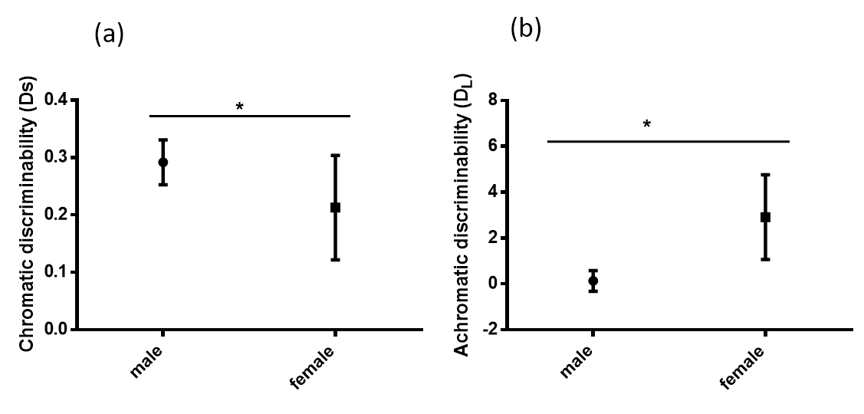

Supplementary figure S1: a) Chromatic (DS) and b) Achromatic discriminability (DL) of male and female abdominal colouration (segment S8 and S9) in tetrachromatic damselfly visual system.